Python Exercise 1

- Area of Rectangle :

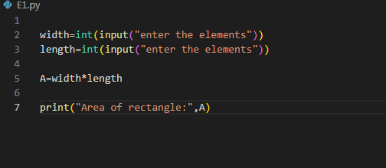
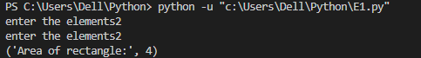

- Area of square :
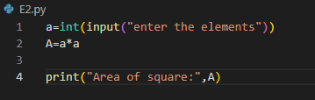
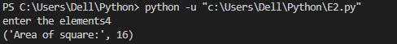

- Area of circle :
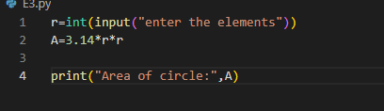
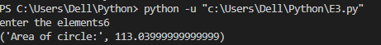

4) average of 5 numbers :
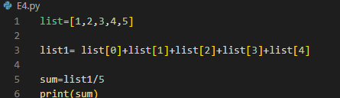

5)Even or add Number :

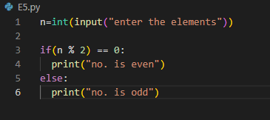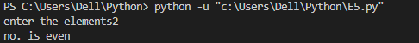

- Leap year or not :
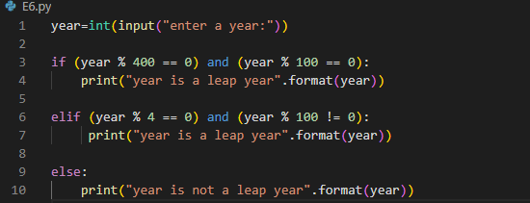
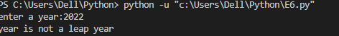

- Postive or negative or zero value :
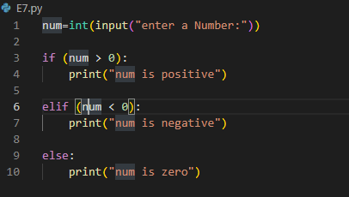

8) check Greater number and Equal number :
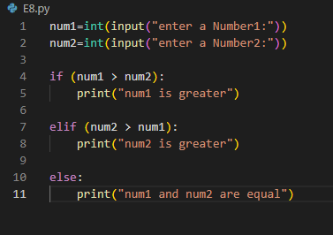
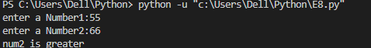

9) factorial :
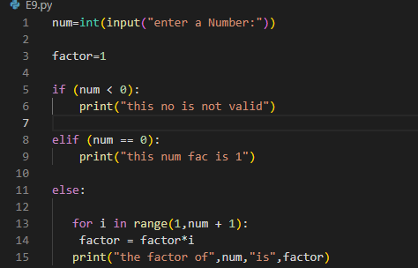

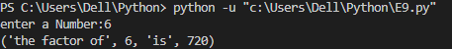

10) swap 2 numbers using third variable :
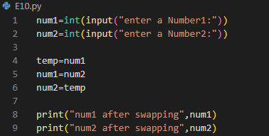
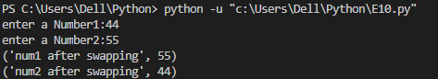

11) find the smallest number in two numbers:
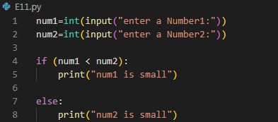
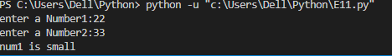

12) check a number is odd or even if number is less than 100 :

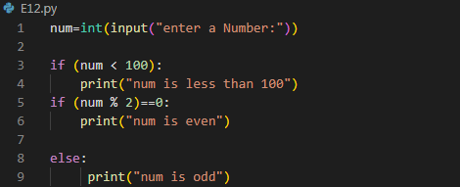
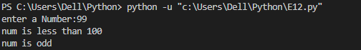

- Sqaure of number if it is less than 10 :

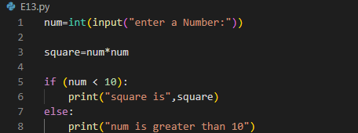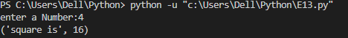

14) check positive ,negative , zero values using nested if else :
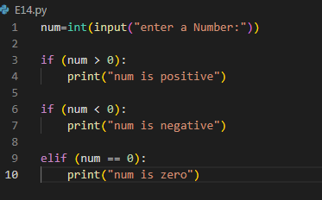

15)swap 2 numbers without using third variable:
